DOCUMENT 1: MERGE SORT - Complete Analysis
MERGE SORT
1. Introduction
Merge Sort is a classic divide-and-conquer sorting algorithm that divides the input array into two halves, recursively sorts them, and then merges the sorted halves.
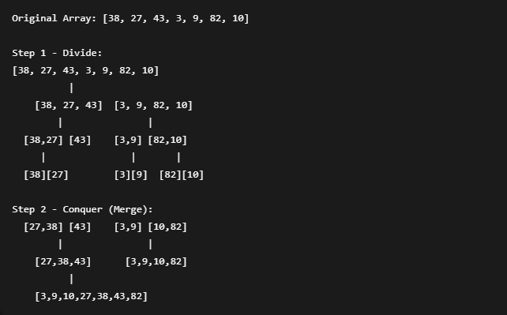
2. Algorithm Visualization

3. Complete C++ Implementation
mergeSort.cpp
4. Complexity Analysis
Complexity | Value | Explanation
Time (Best) | O(n log n) | Always divides array into halves
Time (Average) | O(n log n) | Consistent performance
Time (Worst) | O(n log n) | No worst-case scenario
Space | O(n) | Needs temporary arrays for merging
Detailed Time Calculation:
- Divide step: O(log n) levels of recursion
- Merge step: O(n) work at each level
- Total: O(n log n) = n × log₂n operations

5. Step-by-Step Trace Example
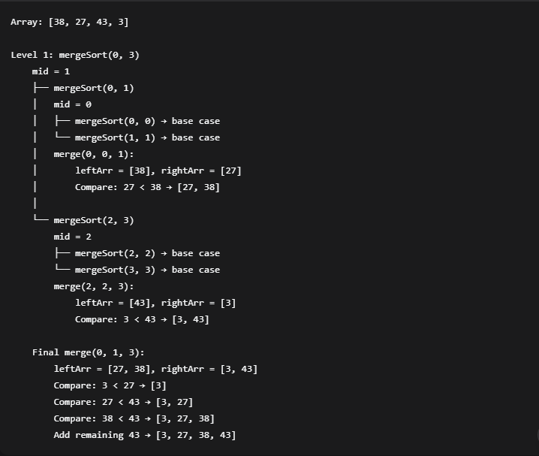
6. Advantages & Disadvantages
Advantages:
- ✅ Stable sorting algorithm
- ✅ Guaranteed O(n log n) time complexity
- ✅ Works well for linked lists
- ✅ Parallelizable
Disadvantages:
- ❌ Requires O(n) extra space
- ❌ Not in-place sorting
- ❌ Slower for small arrays compared to simpler algorithms
7. Common Interview Questions
- Why is Merge Sort preferred for linked lists?
  - Linked lists don't require extra space for merging
  - No random access needed
- When would you not use Merge Sort?
  - When memory is limited
  - When array is nearly sorted (Quick Sort better)
  - For small arrays (Insertion Sort better)

